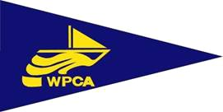

WEYMOUTH AND PORTLAND CRUISING ASSOCIATION
ANNUAL GENERAL MEETING TO BE HELD AT CCSC
Tuesday 29th March 2022

A G E N D A

1. APOLOGIES FOR ABSENCE
2. 2021 MINUTES AND MATTERS ARISING
3. PRESIDENT’S ADDRESS
4. TREASURER’S REPORT AND 2021 ACCOUNTS
5. MEMBERSHIP SECRETARY’S REPORT
6. MOORING OFFICER’S REPORT
7. CRUISING OFFICER’S REPORT
8. SOCIAL SECRETARY’S REPORT
9. PRESENTATION OF TROPHIES
10. ELECTION OF OFFICERS AND COMMITTEE MEMBERS
PRESIDENT
HONORARY SECRETARY
TREASURER
MOORING OFFICER
MEMBERSHIP SECRETARY
CRUISING OFFICER
SOCIAL SECRETARY
CRUISING OFFICE

